**Artistic Vision**  
The artistic vision of this project is to create a simple smooth model shape with creative textures to add a cartoon style of detail. The game strives to maintain a blend of lightheartedness and seriousness of mood.  Textures were chosen to clash the simple design of human assets with the more complex design of the sea creatures to create a greater relative gap between friend and enemy.

**Color**The color scheme was chosen to create a heavy focus on the old school wood, water, and rock motifs. Colors were also chosen to stress nautical warfare as well as lighter blue colors to maintain the lighthearted feel. Creatures’ colors are slightly darker in an attempt to make them more foreboding. Game’s main color palette pictured below.

**Texture**Textures will be abstract blobs of color following the color scheme, and will avoid having solid colored objects to bring more curious detail to simple geometries. The color will be a mix of colors and brushes creating an overall cartoony and borderless feel to the flow of colored assets through characters, creatures, and vessels.

**Model**The model shape will be similar to the simple physical assets used throughout Playmobile® toys, but far from emulating their shape’s precise contours.   
- Characters with have more of a full look, having seemingly larger midsections through their modeling.  
- Creatures will focus more on a serpent-like cylindrical look  
- Ships will emulate more geometrical shapes such as wooden constructions focusing on hexagonal or octagonal shapes, as well as glass for the more advanced government ships.

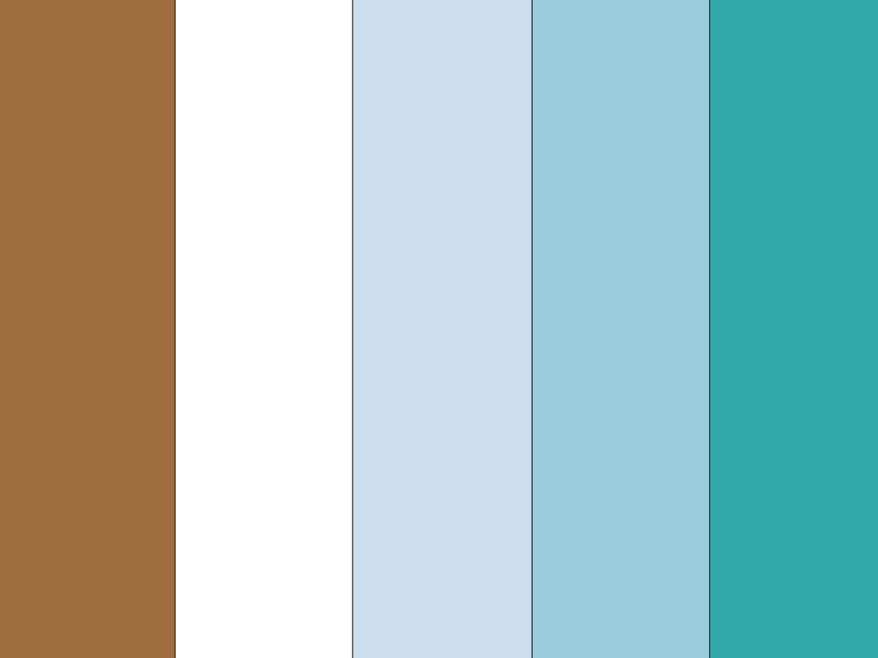

Color palette for game